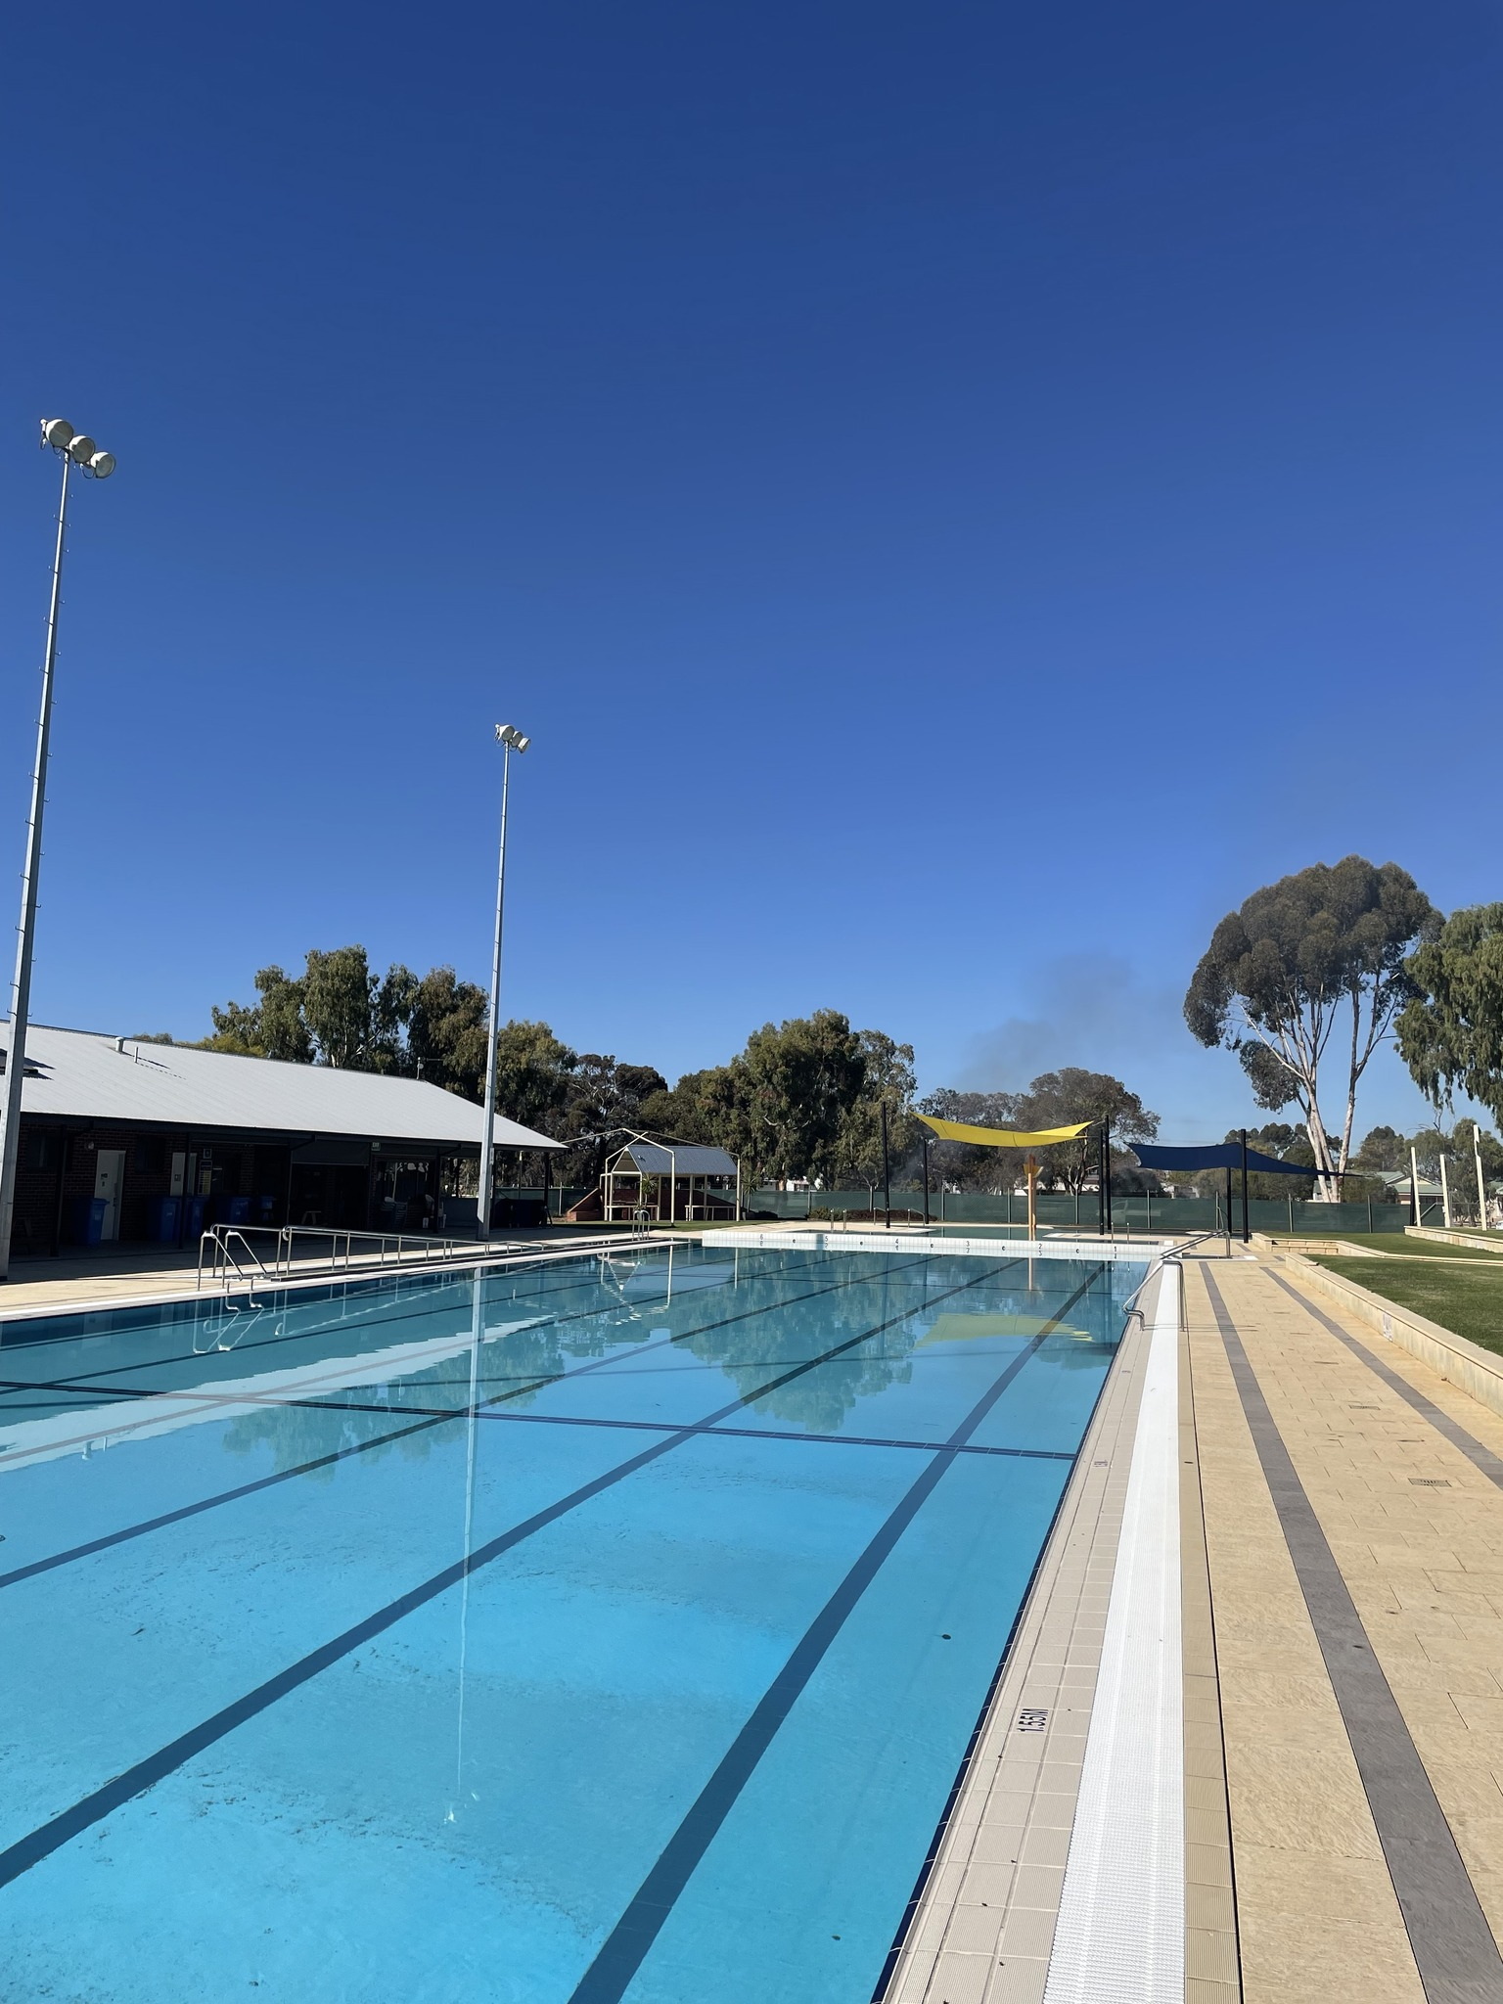



**AGENDA**

**SPORTS & RECREATION**

**ADVISORY GROUP**

16 SEPTEMBER 2024

|  |
| --- |
| **SHIRE OF WAGIN**  **NOTICE OF MEETING** |

**Dear Advisory Group Members,**

**The next Sports & Recreation Advisory Group meeting will be held**

**ON: Monday 16 September 2024**

**WHERE: Wagin Recreation Centre**

**AT: 7:00pm**

|  |
| --- |
| Dr Kenneth Parker |
| **Chief Executive Officer** |

|  |
| --- |
| **SHIRE OF WAGIN**  Agenda for the Sports & Recreation Advisory Group meeting to be held in the Wagin Recreation Centre, Wagin on Monday 16 September 2024 commencing at 7:00pm |

**CONTENTS**

1. OPENING 4

2. ATTENDANCE/APOLOGIES 4

3. CONFIRMATION OF PREVIOUS MEETING MINUTES 4

4. MATTERS FOR DISCUSSION 4

4.1. UPDATE ON ACTIONS TAKEN AT PREVIOUS MEETING 4

4.2. HOCKEY AND CRICKET CLUB FACILITY UPGRADES 5

4.3. INFRASTRUCTURE PRIORITIES 6

4.4. NOMINATIONS FOR AUSTRALIA DAY COMMUNITY AWARDS 7

5. GENERAL BUSINESS 7

6. CLOSURE 7

|  |
| --- |
| OPENING |

|  |
| --- |
| ATTENDANCE/APOLOGIES |

|  |  |
| --- | --- |
| Shire of Wagin |  |
| Cr Phillip Blight | Council Delegate |
| Cr Sherryl Chilcott | Council Delegate |
| Cr Wade Longmuir | Council Delegate |
| Dr Kenneth Parker | Chief Executive Officer |
| Donna George | Community Liaison Officer |
| Tepora Hotene | Community Development Officer |
|  |  |
| Sporting Club Delegates |  |
|  | Wagin Agricultural Society |
|  | Wagin Bowling Club |
|  | Wagin Basketball Club |
|  | Wagin District Cricket Club |
|  | Wagin Football Club |
|  | Wagin Golf Club |
|  | Wagin Gun Club |
|  | Wagin Hockey Club |
|  | Wagin Netball Club |
|  | Wagin Pony Club |
|  | Wagin Swim Club |
|  | Wagin Tennis Club |
|  | Wagin Trotting Club |
|  | Great Southern Go Kart |
|  |  |

|  |
| --- |
| CONFIRMATION OF PREVIOUS MEETING MINUTES |

|  |
| --- |
| MATTERS FOR DISCUSSION |

|  |
| --- |
| UPDATE ON ACTIONS TAKEN AT PREVIOUS MEETING |

An update will be provided on progress on the following actions taken at the previous meeting:

* Community Recreation Centre roof
* Community Recreation Centre floor
* Football Club Dugouts

|  |
| --- |
| HOCKEY AND CRICKET CLUB FACILITY UPGRADES |

Approvals for the demolition of the Cricket and Hockey Club building have occurred. The demolition contractor is awaiting some dry weather to complete works. Demolition was planned to occur between September and November and is still well within the project timetable.

On Thursday, 15 August 2024 Officers and representatives of the Cricket and Hockey Clubs met with Buildcraft who presented a possible design for the pavilion.

Buildcraft had been commissioned to prepare an elevated design for the pavilion that would be suitable for going to tender.

Club officials expressed their satisfaction with the design and worked with Buildcraft to sketch amendments to the internal layout of change rooms and toilets.

Both the external design and the internal design with the club’s markups are shown below:

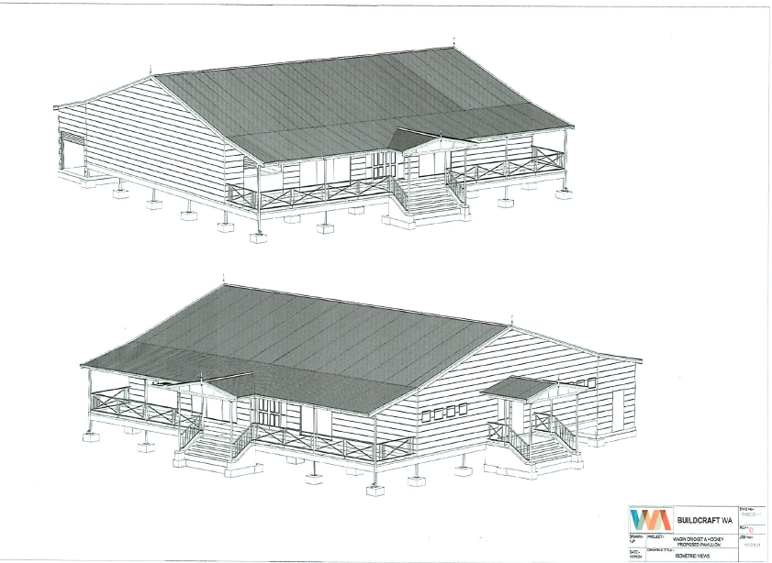

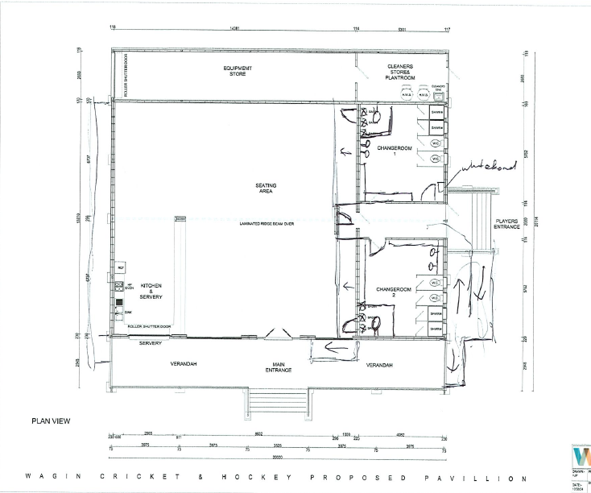

A request for quote has been issued. Reflecting the market conditions, the Shire has already received several replies to the negative.

Submissions close on 27 September 2024.

|  |
| --- |
| INFRASTRUCTURE PRIORITIES |

With the 2025 Commonwealth and State Government elections, it is timely to consider future infrastructure priorities.

Grant opportunities appear on occasion and to seize on these opportunities it is useful to have a wish list waiting in reserve.

For example, the Shire recently applied on behalf of the Bowls Club for lighting through the State Government Club Nights program. This occurred because the Bowls Club made representations to the Shire.

With a relatively new executive in place, the Shire isn’t aware of the history or the priorities of clubs.

The recently adopted Corporate Business Plan includes exploration of a pump track and Officers would observe that the Basketball Courts at the showgrounds have seen better days.

Officers also received a request for a moveable digital scoreboard that could be used by various clubs.

Council looks favourably on requests that involve co-contributions from the clubs. External funders also require a demonstration of commitment from clubs and information regarding sustainability to support their application.

Officers would like to invite clubs to make provide their infrastructure priorities. These infrastructure priorities will be catalogued along with wider community infrastructure priorities (playgrounds etc) and assist in budget planning for future years.

|  |
| --- |
| NOMINATIONS FOR AUSTRALIA DAY COMMUNITY AWARDS |

The nomination period for Australia Day community awards opens shortly. This is a good opportunity to recognise the contribution that volunteers in clubs make.

|  |
| --- |
| GENERAL BUSINESS |

|  |
| --- |
| CLOSURE |